Electronic Products and Solutions Group

PGU
SPD
Webdoc Version of document:
Author:
Anurag Dhar
Trace Control
Porting on Windows CE


Not yet entered

1. Trace Control on Desktop an Overview 3
1.1. Architecture of Trace Control 3

2. Versions of Trace Controls Available While Porting 4
2.1. Trace Control having Control layer in .Net Managed C++ 4
2.2. Trace Control having Control layer in ATL C++ 4
2.3. Version of Trace Control Selected for Porting 4
3. Modifications required for Porting ATL C++ Trace Control in Windows CE 5
3.1 Modifications Required in Control Layer 5
3.2 Modifications required in Core API 5
4. Requirements from the Trace Control in Windows CE: 6
5. Options available while porting ATL C++ Trace Control 6
5.1 Rewrite the Control Layer in C#. 6
5.2 Convert the ATL control to Windows CE MFC Control 7
5.3 Convert the ATL control to Windows CE ATL Control 8
5.4 Approach Adopted for Porting 9
6. Issues faced while porting the Trace Control in Windows CE 10
6.1 Replacing non existing APIs and functions 10
6.2 Threading model 12
6.3 Registering DLL 12
6.4 Using the ATL control in Windows CE application 12

Trace Control on Desktop an Overview

The Trace Control is a desktop ATL Control developed in Agilent for displaying 2D graphics. Though complex Trace control is fast and has small memory footprint.

Architecture of Trace Control

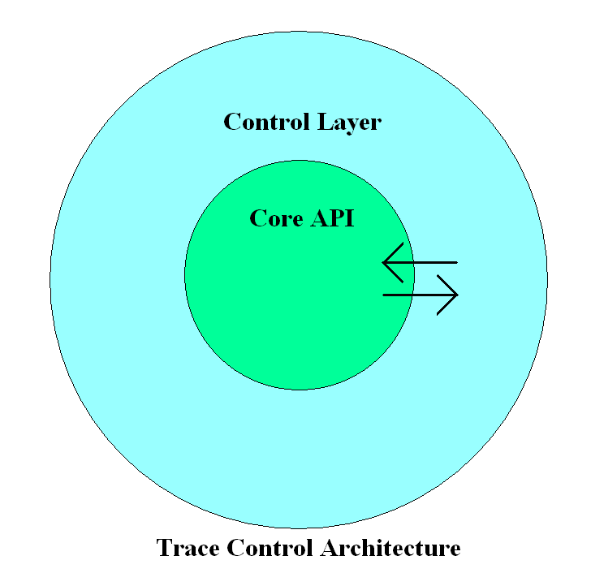
Figure 1

The Trace control contains two components

Core APIs: Core API files are C++ files containing major portion of code. All display related processing is done here. Core API module has dependency on the Control Layer and uses Win32 APIs for display related operations.

Control Layer: Control Layer provides the Core API module to be used as a control in windows environment. The Control Layer acts as a wrapper between host and Core API, however Control Layer and Core API have tight coupling among themselves making these two modules dependent on each other.

Versions of Trace Controls Available While Porting
While starting the porting we had these two versions of Trace Control available and we had to choose any one of them for porting to Windows CE environment.

Trace Control having Control layer in .Net Managed C++

Managed C++ is Microsoft's set of deviations from C++, including grammatical and syntactic extensions, keywords and attributes, to bring the C++ syntax and language to the .NET Framework. Managed C++ is not a complete standalone, or fully fledged programming language. These extensions allow C++ code to be targeted to the Common Language Runtime (CLR) in the form of managed code as well as continue to interoperate with native code.

Trace Control having Control layer in ATL C++

The Active Template Library (ATL) is a set of template-based C++ classes that simplify the programming of Component Object Model (COM) objects. The COM support allows developers to easily create a variety of COM objects, OLE Automation servers, and ActiveX controls.

Version of Trace Control Selected for Porting

Windows CE does not support Managed C++, hence we can’t use Managed C++ version of Trace Control in our application. On the other hand C++ is well supported by the windows CE hence we can use ATL C++ version of Trace Control in our application after appropriate porting.

Modifications required for Porting ATL C++ Trace Control in Windows CE

As we have seen in the Fig.1 the trace control is divided in two modules each performing different task therefore the requirement and approach for porting was also different for these two modules.

3.1 Modifications Required in Control Layer

Windows CE is a more compact operating system than Windows-based desktop platforms, so ATL for Windows CE supports a streamlined subset of the standard ATL library. ATL for Windows CE does not support the following standard ATL features:
- Out-of-process servers :
ATL for Windows CE supports only in-process servers, not out-of-process servers. An in-process server is a DLL that is loaded directly into the address space of the calling process. An out-of-process server is a stand-alone executable that runs in its own address space. Because an in-process server runs in the same address space as its host, it does not incur the overhead associated with cross-process marshalling on every call. We don’t have to do porting for this feature as Trace Control is in proc server.
- Apartment threading model :
ATL for Windows CE does not support the apartment threading model because the apartment model requires more memory resources than the single threading and free threading models. Part of the overhead of the apartment threading model is its built-in marshalling support. Because Windows CE supports only in-process servers and does not support marshalling, it saves both memory and performance overhead by supporting only the single and free threading models.
- Asynchronous monikers :
Windows CE does not support asynchronous monikers, so ATL for Windows CE does not support the CBindStatusCallback class. We don’t have to do porting for monikers as Trace Control is not using this feature.

3.2 Modifications required in Core API

Windows CE supports about 700 of the most-frequently-used Win32 APIs but not all of them. The Trace control Core API is using many such Win32 APIs that are not supported in the Windows CE. We will have to replace such APIs by our own code.

Requirements from the Trace Control in Windows CE:

1. The trace control is a graphics display involving lots of computation hence it should be fast.
2. The trace control is to be used on the device having limited processing power.
2. The trace control has to run on the device having smaller physical memory than desktop computer.
3. Being a graphics display the operations inside trace control should be as fast as possible to avoid flicker.

In summery the most critical requirement from the display module is fast operating speed and small size of memory footprint.

Options available while porting ATL C++ Trace Control

These options were available while porting:

5.1 Rewrite the Control Layer in C#.

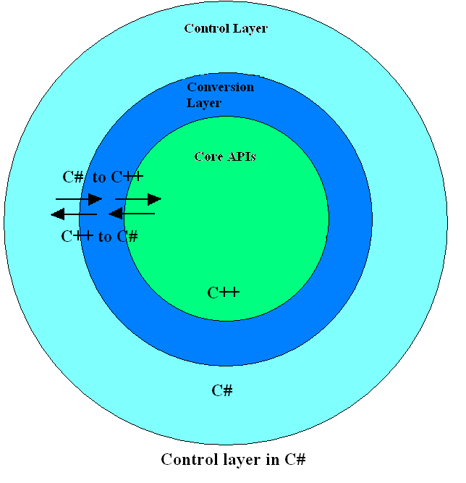
Figure 2

If we rewrite the control layer in C# then we will have the ease of using C# control from C# application, however this will introduce additional complexities in Trace Control .As we see in the Fig .1 the Core API and Control layer modules have strong coupling with each other. If we code control layer in C# then we will have to call C# code from the C++ and C++ code from C#. This will involve a lot of pointers and complex structures conversion. Some of the structures are having more than 400 members.
For all this conversion we will have to introduce another layer between these two modules. This layer will be used for conversion between managed and unmanaged code. The introduction of this layer in the Trace Control will cause the performance of trace control go down. Furthermore the reverse engineering, designing, coding and testing of such implementation will be a huge task.

5.2 Convert the ATL control to Windows CE MFC Control

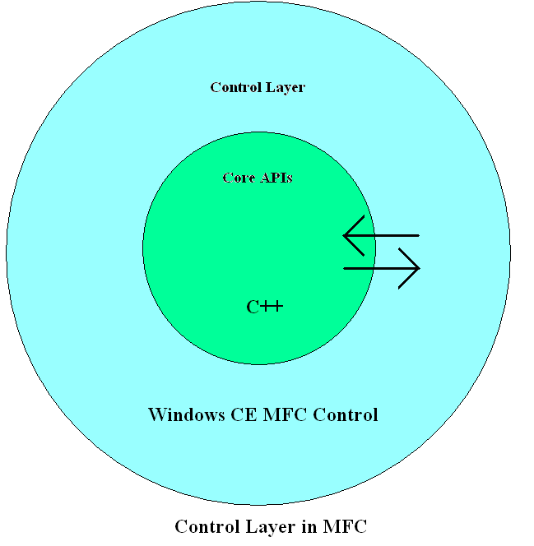
Figure 3
The Microsoft Foundation Class Library (MFC) for Windows CE is a both a powerful class library and a complete object-oriented application framework for creating Windows CE programs in C++.
MFC for Windows CE supports stand-alone executables and dynamic link libraries (DLLs). With MFC, developers can create anything from a simple dialog box-based program to a powerful sophisticated application that employs the MFC document/view architecture. MFC for Windows CE can also be used to create full-featured ActiveX controls and containers.

5.3 Convert the ATL control to Windows CE ATL Control

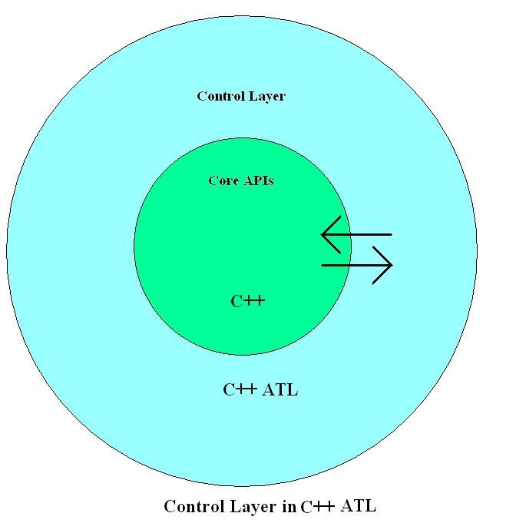
Figure 4

The Active Template Library (ATL) for Windows CE is a specially-designed C++ template library so that ATL components only implements the specific interfaces that project requires. It is designed and optimized to help create the smallest and fastest ActiveX components possible.

5.4 Approach Adopted for Porting
ATL for Windows CE is expressly designed for creating ActiveX controls and other COM components, so ATL components only implement the specific interfaces that project requires. Because of this, code created using ATL is smaller, faster, and more efficient than code created using MFC.

As ATL is a fast and easy way to create a COM component in C++ and maintain a small footprint and we don't need all of the built-in functionality that MFC automatically provides, therefore our preference is Windows CE ATL control.

Issues faced while porting the Trace Control in Windows CE

6.1 Replacing non existing APIs and functions
There were many win32 APIs used in Trace Control which are not available with Windows CE. The alternatives of such API’s were found. In case no alternative was available these APIs were rewritten in Core API module. Some of such APIs are:-

1. STDAPI OleCreateFontIndirect(
FONTDESC* pFontDesc, //Pointer to the structure of parameters for font
REFIID riid, //Reference to the identifier of the interface
VOID** ppvObj //Address of output variable that receives the interface pointer requested in riid
);
Description:
This API is used in the constructor of trace control to create font.
Sol.
In windows CE we are using MFC mechanics to create font.

CFontHolder fontHolder(NULL);
fontHolder.InitializeFont(&fd, NULL);
m_pFont = fontHolder.GetFontDispatch(); //Get a pointer to the CFontHolder object’s IFontDisp interface.
fontHolder.ReleaseFont();

2. BOOL Arc(
HDC hdc, // handle to device context
int nLeftRect, // x-coord of rectangle's upper-left corner
int nTopRect, // y-coord of rectangle's upper-left corner
int nRightRect, // x-coord of rectangle's lower-right corner
int nBottomRect, // y-coord of rectangle's lower-right corner
int nXStartArc, // x-coord of first radial ending point
int nYStartArc, // y-coord of first radial ending point
int nXEndArc, // x-coord of second radial ending point
int nYEndArc // y-coord of second radial ending point
);

Description:
This API is used to draw circle in with given parameters.
Sol.
We are using Ellipse GDI to draw the circle.

4. HRGN CreatePolygonRgn(
CONST POINT *lppt, // array of points
int cPoints, // number of points in array
int fnPolyFillMode // polygon-filling mode
);
Description:
This API is used to create a polygonal region with given parameters.
Sol.
We are using our own algorithm to create polygon region.

5. BOOL LPtoDP(
HDC hdc, // handle to device context
LPPOINT lpPoints, // array of points
int nCount // count of points in array
);
Description:
This API is used to logical coordinates into device coordinates.
Sol.
In Windows CE the device coordinates are always same as logical coordinates, so we are simply commenting the GDI call.

6. int GetMapMode(
HDC hdc // handle to device context
);
Description:
This API is used to retrieve the current mapping mode.
Sol.
In Windows CE, we cannot change the window and viewport origins or extents, which mean that device coordinates are always the same as logical coordinates.

7. int SetMapMode(
HDC hdc, // handle to device context
int fnMapMode // new mapping mode
);
Description:
This API is used to create a polygonal region draw circle in with given parameters.
Sol.
Transformation functions of coordinate space, such as SetMapMode, GetMapMode, SetViewportExt, and SetWindowExt. Coordinate space is equivalent to device space hence we have just commented the code.

8. BSTR ConvertStringToBSTR (const char* pSrc)
Description:
Converts a char * value to a BSTR.
Sol.
We have added our own implementation of this function as:
namespace _com_util
{
BSTR __stdcall ConvertStringToBSTR(const char* pSrc) {
CComBSTR s = pSrc;
return s;
}
}

10. void com_issue_error(long code)
Description
Com error supporting function
Sol.
This function is not implemented in Windows CE hence we have added our own implementation as:

Void __cdecl _com_issue_error(long code)
{
static unsigned long lcode = code;
RaiseException(0xe06d7363, 0, 1, &lcode);
}

6.2 Threading model

ATL for Windows CE does not support the apartment threading model therefore the ATL objects which were inherited from the single threaded model were instead inherited from multi thread class, also the registry settings of such ATL objects were modified to free Threading model.

6.3 Registering DLL
Before using the ATL control in windows CE we have to register control’s Dll first. To register the Trace Control Dll we had to find all the Dlls on which Trace Ctrl depends and place these DLLs in windows folder. Having done that we made a tool for registering DLL on CEPC machine. This tool registered the Trace Control on the CEPC platform to test our control.

6.4 Using the ATL control in Windows CE application
Microsoft has not provided control hosting in .NET Compact Framework 2.0.Therefore in order to use the ATL control as a design time (drag and drop) control in .net we wrote windows CE 5.0 Control as a wrapper on the ported ATL control.
For more detailed explanation on using ATL control in windows CE click here Http://msdn2.microsoft.com/en-us/library/aa446515.aspx

